**Syllabus**

**BIO 282 – Endangered Species Biology**

**Block 2, 2018**

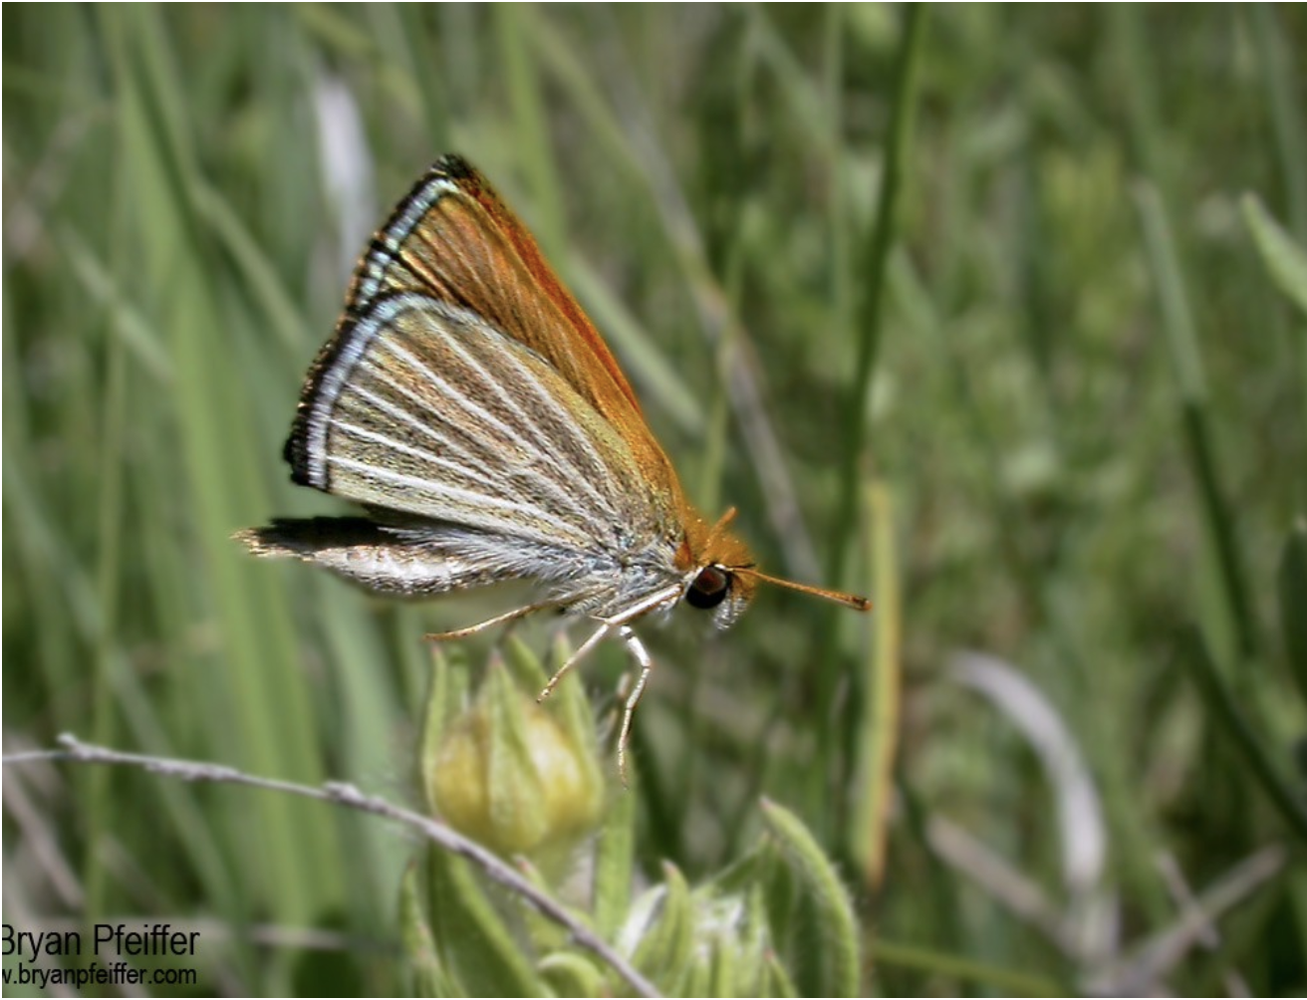

**Dr. Tammy Mildenstein**, West Science 108A, Phone: 319-895-4494

Email: [tmildenstein@cornellcollege.edu](mailto:tmildenstein@cornellcollege.edu)

Office Hours: I am generally around my office before and after class, from 11:00 to 1:00, and always am

willing to meet by appointment. If you don’t see me, email me!

**Meeting times:** 9:30 – 11:00 AM, 1:00 – 3:00 PM; West Science, Room 201

Times and locations of field trips will vary.

**Course Description:** This course is designed for students majoring in environmental studies and/or organismal biology interested in learning about endangered species. This course investigates the biology and ecology of endangered species.  Using case-studies and real-world examples, students will explore factors that contribute to species endangerment such as habitat degradation and loss, anthropogenic disturbance, unregulated hunting pressure, natural and human-caused rarity, and ecological specialization.  Students will also learn how they, as biologists, can make a difference, using modeling tools like population viability analysis to predict population persistence, and applying biological and ecological strategies to plan for the recovery and sustainable management of species of concern

*This course supports the Educational Priorities and Outcomes of Cornell College with emphases on knowledge, inquiry, reasoning, communication, ethical behavior, citizenship, vocation, and well-being.* These *Educational Priorities and Outcomes* can be found in the Academic Catalogue

*Knowledge*: The course will introduce you to aspects of conservation biology relevant to wildlife issues at the local, national, and international levels.

*Inquiry and reasoning:* My goal is to guide the class in developing and conducting a conservation-focused project on a locally threatened species. In the process, we will read and critique the peer reviewed literature in ecology and gain a background on different approaches to wildlife conservation.

*Communication*: Students will write a paper on an endangered species of their choice. Students will also be asked to lead in-class discussions and be prepared to ask questions in lectures, guest lectures, and discussions led by their peers.

*Ethical behavior*: As a class, we will discuss environmental conservation ethics and value-based approaches to wildlife conservation.

*Citizenship and vocation*: Students will take part in wildlife conservation service projects within the local community, working with Non-Governmental Organizations, and government agencies, as well as meeting with professional biologists and managers engaged in conservation-focused activities.

**Readings and Textbook:** The book we are using is called Conservation of Wildlife Populations, by L. Scott Mills. This is a great book that outlines endangered species assessment and conservation from a population management perspective, but it is geared for upper level undergraduate students and can be challenging at times. This book is required for the course and therefore is now available at the Cornell Bookstore. Throughout the block there will be some additional required readings, which will be placed on the course website before lectures. All information from the book and other readings will be testable.

**Website:** We will be using Moodle as our course website. Once you are registered for the course, you can login to access lectures, assigned readings, and other course documents.

**Class Format:** This class will make use of lectures, student-led discussions, student group projects, and field trips to impart important principles of wildlife conservation and provide opportunities to get involved in a meaningful way.

LECTURES will be given by me (the instructor) as well as by guest lecturers who are professionals in the field of wildlife conservation. Instructor lectures will be primarily PowerPoint based and made available on the course Moodle website AFTER lectures for downloading and reviewing. Discussion of assigned readings will be included. Guest speakers will be given their choice of teaching format. Whenever possible, we will request copies of their presentation material, but this is not guaranteed.

STUDENT-LED DISCUSSIONS will provide students with a way to present material they learned to the class and engage classmates in discussion about the material. Sometimes individually and sometimes with a partner, each student will be asked to lead a discussion/present material at a minimum of once per week.

GROUP PROJECTS are an opportunity to get to know local wildlife issues and conservation problems. Students will be able to form groups and choose a local topic to focus their research on. Together the student group will present an overview of their conservation problem, write a paper on their conservation problem, and support conservation management in one tangible way (e.g. hands on work, producing outreach materials, etc.)

FIELD TRIPS to local natural areas and conservation programs will be once/week. As much as possible, field trips will take place during regular class hours. However, these trips may occur outside of class hours to take advantage of special wildlife-focused happenings!

All material covered (i.e. not just powerpoint lectures) will be considered testable class content.

**Class participation:** In small classes, especially with cooperative group projects, participation is of utmost importance. A substantial part of your grade and most of your success in this class will be based on your ability to prepare for class and contribute to discussions. Because you will be working in small groups, your peers will also be asked to weigh in on your participation grade, and you will be asked to rate your peers.

**Assignments:** To encourage students to keep current with course material will have six, short unannounced assignments and/or quizzes (5 pts each). Any short quizzes/assignments given as a take home assignment may be turned in on Moodle.

In addition to the unannounced short assignments, the course will include four longer assignments related to the lectures and/or field trips. This will give students opportunities to demonstrate what they are learning. Assignments will be written in full sentences and spell checked, and submitted via Moodle in .docx format. I do not accept assignments in the form of a google.doc, because the formatting is often compromised when I download them on my computer.

The group projects will be explained in more detail in class. This assignment will be worth as much as one of the exams and is designed to allow you to learn at your own pace on a wildlife conservation subject of your choice.

**Exams:** There will be two exams in this class (one mid-term and a final). Each exam may consist of multiple choice, true-false, short answer and short essay questions. Emphasis on exams will be to test whether students learned key material presented in lectures and readings, whether students can synthesize materials into their own understanding of wildlife conservation, and be able to problem solve in new situations. Course material in lectures, readings, and field trips will be considered for all exams. The midterm exam will cover all course content up to the class prior, and the final exam will cover the entire course *though synthesis of the course material will be emphasized.*

Time for exams will be allotted from the regular course time, 9:00-11:00 AM but students are allowed to stay after 11:00 AM to finish if they require extra time.. Students arriving at a scheduled exam AFTER the first person finishes the test will not be allowed to take the exam. *Use of cell phones, mobile phones or smart phones WILL NOT BE ALLOWED.* Make-up exams will be scheduled **only given notification of a valid excused absence** (see attendance below). Students will have two days following return to school to schedule exams – this will be your responsibility.

**Final Exam Time:** 9:00-11:00, Tuesday, October 16, 2018 (Let me know RIGHT away if you have a conflict)

|  |  |  |
| --- | --- | --- |
| **Course Grading** | **Total** | **%** |
| Class participation (instructor/peer review) | 30 | 10% |
| Quizzes/reflections (6) | 30 | 10% |
| Assignments (4) | 70 | 23% |
| Midterm exam | 50 | 17% |
| Endangered Species Project Presentation | 20 | 7% |
| Endangered Species Paper | 50 | 17% |
| Final Exam | 50 | 17% |
|  | 300 | 100% |

Grades will be based on your % of total points in the class: A > 90%; B > 80%; C > 70%; D > 60%; F < 60% (I do consider + and – within 2 points of the cut-off thresholds).

**Course Policies**

Cornell academic policies can be found in *The Academic Catalogue* <http://www.cornellcollege.edu/registrar/catalogue-course-info/catalogue.pdf>

**Attendance Policy:** Attendance will not be recorded in lecture because your desire to learn will dictate your presence. Students are individually responsible for all information presented in lectures, guest lectures, field trips, and readings. **No make-up exams will be scheduled.** In the case of medical or family emergency (e.g., legitimate, planned absences) I will work with the student individually in terms of rescheduling exam times etc. **Formal health care documentation will be required for legitimate health care issues.**

Habitual tardiness or multiple absences will negatively affect your participation score. If you know you are going to be late or miss a class, please inform me beforehand. If you are sick, you must obtain documentation from the health center in order to get an excused absence or a health withdrawal. If you do not need medical attention, you still need a note. If you are late for a field trip, expect to be left behind.

**Field Trips:** Field trips will not be far, but to take advantage of the warmest part of the day, may include lunch in the field. I will let you know about these ahead of time. Dress appropriately. We will be outside. That means long pants and closed-toed shoes (preferably boots). I strongly recommend long sleeves, warm jackets, and a hat. Rain gear is also a good idea, even if rain is not predicted.

**Computer accounts:** I expect to communicate with you electronically and expect you to use computers for lab work. This requires that you have a computer account with Cornell. If you do not have one, please get one today. If this is a problem for you, please talk to me, but my policy is to use no other accounts for e-mailing my students. The College’s policy states that electronic communications are as official as written communications and that you are expected to check your email daily when you are on campus.

**Mobile Phone Policy:** Mobile phone use is disruptive to both your own, your fellow students learning, and my teaching. No use of mobile phones will be permitted in class. If you are using your phone for any reason during class you will be excused until the next break. Multiple violations will result in reduced grades for the class.

**Email Policy:** Like you, instructors get many, many email messages a day. Please understand that email response times may be slow at times. As always, remember that email messages to course instructors should be more like letters than text messages. Please use full sentences and English writing style with no spelling mistakes, a CLEAR subject line that CLEARLY identifies the COURSE CODE [i.e., Subject: BIO 108 question from student X], and a clear, concise question.

**Office Hours:** Meeting with the professor for a course can be a useful way to overcome obstacles to learning,

understand key concepts, and improve your learning experience. Please come and see me if you have any questions. My office hours are times when I am usually in my office or around West Science somewhere. Feel free to just drop in during these times, but if you really need to meet with me, it is a good idea to make an appointment in advance. I will be happy to make appointments for any time I am not otherwise occupied.

**Students with disabilities:** Students who need accommodations for learning disabilities must provide documentation from a professional qualified to diagnose learning disabilities. For more information see [www.cornellcollege.edu/disabilities/documentation/index.shtml](http://www.cornellcollege.edu/disabilities/documentation/index.shtml) Students requesting services may schedule a meeting with the disabilities services coordinator as early as possible to discuss their needs and develop an individualized accommodation plan. Ideally, this meeting would take place well before the start of classes.

**Academic Honesty:** Trust between student and instructor is of paramount importance in academic settings. Academic dishonesty will not be tolerated in the classroom. Cornell College expects all members in the Cornell community to act with academic integrity. An important aspect of academic integrity is respecting the work of others. A student is expected to explicitly acknowledge ideas, claims, observations, and data of others, unless generally known. When a piece of work is submitted for credit, a student is asserting that the submission is her or his work unless there is a citation of a specific source. If there is no appropriate acknowledgement of sources, whether intended or not, this may constitute a violation of the College’s requirement for honesty in academic work and may be treated as a case of academic dishonesty. The procedures regarding how the College deals with cases of academic dishonesty appear in *The Catalogue*, under the heading “Academic Honesty”.

**Dropping/Adding:** Any student may drop for any reason during the first three days of class. To drop on the 15th day, you must have "made a determined effort to master the material and to participate in class" (see the Catalog). This involves a minimum of regularly attending class, turning in all assignments, and participating as a member of the team in all aspects of the trip and field project.